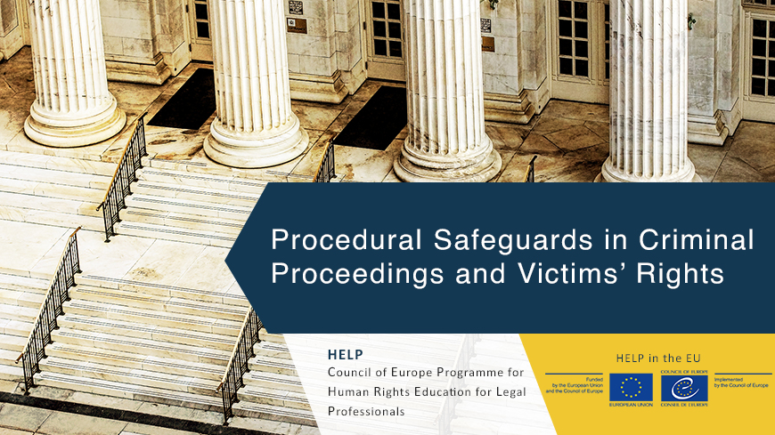
HELP Thematic Seminar
Procedural Safeguards in Criminal Proceedings and Victims’ Rights

Rights of Persons with Disabilities
Date and location : 14-15 June 2023, Sofia (Bulgaria)
Format : face-to-face seminar followed by online course
Duration: 1.5 days (thematic seminar); 10-12 weeks (online course)
Open to : lawyers from Bulgaria and Greece
Languages : English (seminar); Bulgarian and Greek respectively (online course)
Organised by : the CoE HELP Programme in cooperation with the Bulgarian Bar Association and the Athens Bar, under the EU-CoE Judicial Training on Rule of Law and Fundamental Rights
Registration : via the Bulgarian/Greek Bar

Table of Contents
Background 2
The thematic seminar 2
Participation 3
Further information 3
Agenda 4

Background

The Council of Europe (CoE) Programme for Human Rights Education for Legal Professionals (HELP) is aimed at supporting the CoE member States in implementing the European human rights standards at the national level, focusing on the European Convention on Human Rights (ECHR), other key CoE instruments, and since 2015, EU law. This is done by raising the capacities of legal professionals to apply those instruments in their daily work.
The objective of HELP is to provide high quality education on human rights to judges, lawyers and prosecutors throughout Europe. Law enforcement authorities such as police and prison staff are also targeted by HELP. Thanks to HELP courses, legal professionals can better protect human rights on a national level and keep up to date with the ever-evolving standards and case law of the European Court of Human Rights (ECtHR). HELP courses specifically designed for EU countries increasingly incorporate relevant EU laws.

HELP is:
1. the only pan-European Network of national training institutions for judges, prosecutors and lawyers in the 46 CoE Member States.
2. an e-learning platform with free on-line courses on human rights.
3. a human rights training methodology for legal professionals.

The thematic seminar
Cross-border thematic seminar will provide an opportunity for transnational and multi-agency exchange of information and best practices on the core aspects related to criminal trials, namely the rights of the defence and the rights of the victims. The seminar will explore several components related to the rights of the accused and those of the victims, in light of the European standards on the matter, stemming from the CoE and the EU frameworks and the ECtHR and CJEU case-law. It aims to create a forum for practical exchanges among lawyers working in the criminal field, by providing them with the relevant information on the main challenges in the application of these standards in their respective countries. They will also have the opportunity to learn from their peers and gain a comparative perspective drawn from the Bulgarian and Greek contexts. In order to be able to deepen their discussions and follow up on the exchanges, participants will continue with the implementation of the HELP course on Procedural Safeguards in Criminal Proceedings and Victims’ Rights, assisted by their respective national tutors.

Before the seminar, participants should create an account on the HELP e-learning platform

For creating your HELP account, please follow these steps:
- go to this link and fill in the form (it takes about 2 mins): https://help.elearning.ext.coe.int/login/signup.php
- once submitted, you will receive an activation link on the email you used for creating the account
- go to your email inbox and click on the link to activate your account.

During the seminar, the participants will be registered on their course page, prepared in advance by their national tutors. Over the following 10-12 weeks and based on the planning set by the tutor, the participants will go through the online course, complemented by the national course adaptation prepared by the tutor.
The participants who have successfully completed the course and passed the evaluation set by the tutor will receive certificates issued by the HELP Programme of the Council of Europe.

Participation

Interested participants should:
- be available to attend the thematic seminar
- undertake to also follow and complete the online tutored course in the following 10-12 weeks (approx. 1-2 hours of work per week)
- register for the event as indicated

The trip to Sofia will be covered by the project. Participants not residing in Sofia will also receive a daily allowance. Participants that have been selected by their national bar will be contacted by the project team for their travel arrangements.

Further information
Contact:

Agenda

14 June 2023

9.30 – 9.50 | Welcome address  BGR Info Point/ BA rep  GRE Info Point / GRE rep
9.50 – 10.30 | Session 1 – The European framework on the rights of the defence – overview of the CoE and EU standards and relevant case-law  - Specific safeguards under Article 6 para 2 ECHR  - Roadmap Directives and the CJEU case-law  ECHR Registry  FRA
10.30 – 11.00 | Coffee break
11.00 – 12.20 | Discussion on selected cases:  - The concept of “criminal charge”  - Presumption of innocence  - Examination of victims  - European Arrest Warrant  TBC
12.20 – 12.30 | Questions and answers
12.30 – 14.00 | Lunch break
14.00 – 14.40 | Session 2 – The European framework on the rights of victims of crime  ECHR/FRA
14.40 – 15.00 | Discussion on selected cases:  - Access to Justice  - Avoiding revictimization  TBC
15.20 – 15.30 | Questions and answers
15.30 – 16.00 | Coffee break
16.00 – 16.40 | Overview of the relevant resources for legal professionals  - The ECHR KS platform  - The FRA resources  ECHR/FRA
16.40 – 17.20 | Presentation of the HELP Programme and the EU project  Overview of relevant HELP courses  Giulia Lo Presti
17.20 – 17.30 | Q/A and closure of the first day
15 June 2023

9.30 – 10.00 | Session 3 – Implementing European standards at national level  - Overview of the main ECHR pending execution by Bulgaria and Greece  CoE Execution Dept
10.00 – 10.40 | Applying European standards at national level – challenges and perspectives  - The rights of the accused  - The rights of victims of crime  HELP national tutors
10.40 – 11.00 | The HELP course on Procedural Safeguards in Criminal Proceedings and Victims’ Rights  Katarina Spanou
11.00 – 11.30 | Coffee break
11.30 – 12.30 | Follow-up and implementation of the HELP course  Session moderated by the HELP national tutors
12.30 – 13.00 | Q/A session with the national tutors and closure

For more information on HELP please visit HELP’s website: www.coe.int/help

